1. *WordPress is a popular, dynamic, blog-focused content management system*
2. *WordPress is the backbone of most blogs and news outlets.*
3. *WordPress is undoubtedly one of the most popular Content Management Systems (CMS) available in the market.*
4. *WordPress can be installed in multiple ways – one of them is using LAMP. With this method you can host yourvery own WordPress website on a VPS.*
5. *WordPress enables you to easily build your eCommerce store, website, portfolio or blog.*

***Now Install Lamp With Wordpress***

***First install Apache2 server***

apt-get install apache2 -y

systemctl enable apache2

systemctl restart apache2

***Now Install PHP***

apt install php php-curl php-gd php-mbstring php-xml php-xmlrpc php-soap php-intl php-zip -y

apt install php-mysql -y

php -v

***Now Install the MySQL server***

apt install mysql-server -y

***and also install for security purpose***

mysql_secure_installation

***Now Create a Database for WordPress***

mysql -u root -p

mysql> CREATE DATABASE wordpress;

mysql> GRANT ALL PRIVILEGES ON wordpress.* TO 'deep'@'localhost' IDENTIFIED BY 'temp';

mysql> FLUSH PRIVILEGES;

mysql> exit;

***Now Install WordPress in /var/www/html.***

cd /var/www/html

wget -c http://wordpress.org/latest.zip

apt install unzip -y

unzip latest.zip

chown -Rf www-data:www-data wordpress

rm latest.zip

***All the files will be inside wordpress directory in /var/www/html/wordpress***

cd /var/www/html/wordpress

mv wp-config-sample.php wp-config.php

vi wp-config.php

***replacing database_name_here, username_here and password_here with your own data***

// ** MySQL settings - You can get this info from your web host ** //

/** The name of the database for WordPress */

define('DB_NAME', '**wordpress**');

/** MySQL database username */

define('DB_USER', '**deep**');

/** MySQL database password */

define('DB_PASSWORD', '**temp**');

/** MySQL hostname */

define('DB_HOST', 'localhost');

/** Database Charset to use in creating database tables. */

define('DB_CHARSET', 'utf8');

/** The Database Collate type. Don't change this if in doubt. */

define('DB_COLLATE', '');

***Now Create the virtual host configuration file for your domain like deep.com.conf inside a file given below***

vi /etc/apache2/sites-available/deep.com.conf

<VirtualHost *:80>

ServerAdmin admin@deep.com

ServerName deep.com

ServerAlias www.deep.com

DocumentRoot /var/www/html/deep.com

<Directory /var/www/html/deep.com>

Options Indexes FollowSymLinks

AllowOverride All

Require all granted

</Directory>

</VirtualHost>

***Now Launch and Check Configuration test of file ok or not then restart apache2***

a2ensite deep.com

apache2ctl configtest

systemctl restart apache2

***Now Access the WordPress***

***open your browser and navigate to***

http://www.deep.com/wp-admin

**It will show look like below then click continue.**

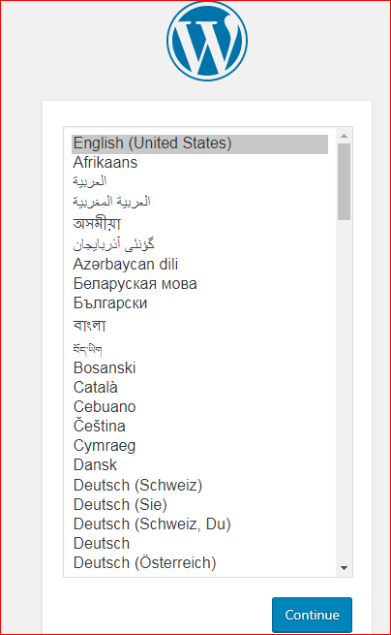

*Then give title ,username and password and also emal then install*

